Virtusa React Training

B Sahil (221910304005)

Day 8

1. Form Validation

Create a form, create 2 text fields – username and pin number, create a button ‘submit’. Condition for username is minimum it need to accommodate 6 characters and criteria for pin is it need to have both capitals and small letters it should not contain special chars.

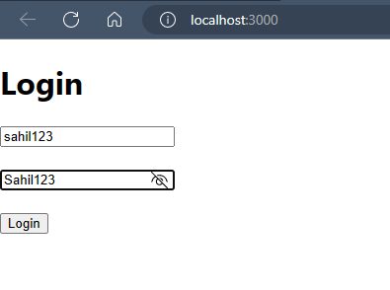

Login.js

import React from 'react';

import { useState } from 'react';

function Login(){

    const[user,setUser]=useState("")

    const[pwd,setpwd]=useState("")

    const[usererr,seterr]=useState(false)

    const[pwderr,setperr]=useState(false)

    function LoginHandle(e){

        if(user.length<6 || pwd.length<6){

            alert("Not Valid")

        }

        else {

            alert("Valid")

        }

        e.preventDefault();

    }

    function userHandle(e)

    {

        let item=e.target.value;

        if(user.length<6){

            seterr(true)

        }

        else {

            seterr(false);

        }

        setUser(item);

    }

    function pwdHandle(e)

    {

        let item=e.target.value;

        if(pwd.length<6){

            setperr(true)

        }

        else {

            setperr(false);

        }

        setpwd(item);

    }

    return (

        <div>

            <h1>Login</h1>

           <form onSubmit={LoginHandle}>

           <input type="text" placeholder="Enter User Id" onChange={userHandle} />{usererr?<span>User Not Valid</span>:""}

            <br /> <br />

            <input type="password" placeholder="Enter User Password" onChange={pwdHandle}/>{pwderr?<span>Password Not Valid</span>:""}

            <br /> <br />

            <button type="submit">Login</button>

           </form>

        </div>

    )

}